**Experiment 5**

**Aim:** Create An Application which has Image, Image map and Image Button.

**Code:**

# WebForm1.aspx

<%@ Page Language="C#" AutoEventWireup="true" CodeBehind="WebForm1.aspx.cs" Inherits="Experiment5.WebForm1" %>

<!DOCTYPE html>

<html xmlns="http://www.w3.org/1999/xhtml">

<head runat="server">

<title>Images</title>

<style type="text/css"> .auto-style4 { margin-left: 0px; margin-top: 0px;

}

</style>

</head>

<body>

<form id="form1" runat="server">

<div>

<asp:Image ID="Image1" runat="server" CssClass="auto-style4" Height="254px" ImageUrl="https://cdni.autocarindia.com/ExtraImages/20200421042327_Ford-Mustang_GT_1.jpg" Width="438px" />

<asp:ImageButton ID="ImageButton1" runat="server" Height="227px"

ImageUrl="https://image.flaticon.com/icons/png/512/55/55299.png" Width="307px" PostBackUrl="https://www.ddu.ac.in/" />

<asp:ImageMap ID="ImageMap1" runat="server"

ImageUrl="https://img.etimg.com/thumb/msid-75549785,width-640,resizemode-4,imgsize-

465423/the-fastest-mclaren.jpg" HotSpotMode="Navigate">

<asp:CircleHotSpot X="317" Y="277" Radius="20"

NavigateUrl="https://www.ddu.ac.in/" AlternateText="Home Page" />

<asp:RectangleHotSpot Bottom="194" HotSpotMode="Navigate" Left="222"

NavigateUrl="https://www.ddu.ac.in/" Right="326" Top="144" />

<asp:PolygonHotSpot Coordinates="334,194 , 424,166, 401,132, 332,124, 336,140" HotSpotMode="Navigate" NavigateUrl="https://www.ddu.ac.in/" />

</asp:ImageMap>

</div>

</form>

</body>

</html>

# WebForm1.aspx.cs

using System;

using System.Collections.Generic; using System.Linq; using System.Web; using System.Web.UI;

using System.Web.UI.WebControls;

namespace Experiment5

{

public partial class WebForm1 : System.Web.UI.Page

{

protected void Page_Load(object sender, EventArgs e)

{

}

protected void ImageButton1_Click(object sender, ImageClickEventArgs e)

{

ltr_click.Text = "<font color=\"#FF4444\"> You click at X = " + e.X.ToString()

+ " Y = " + e.Y.ToString();

}

protected void ImageMap1_Click(object sender, ImageMapEventArgs e)

{

ltrmap_postback.Text = "<font color=\"green\">You selected the " +

e.PostBackValue + "</font>";

}

}

}

**Output**

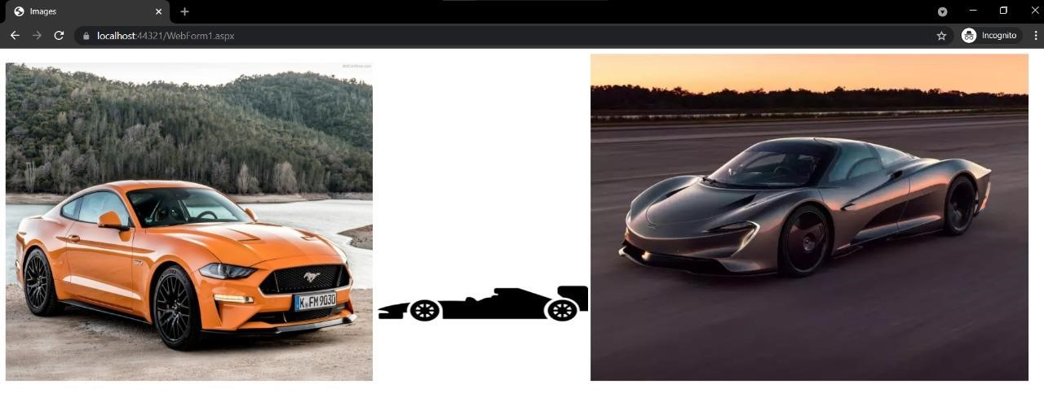

**Fig. Basic Interface**

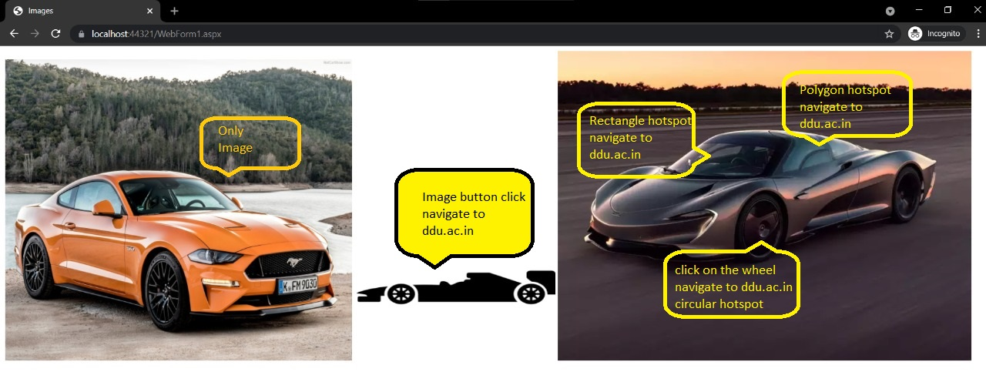

**Fig. All Components**